(Approx. 1105 words)

PC Organization
Author: Dick Maybach, Member, Brookdale Computer User Group, NJ
www.bcug.com
n2nd (at) att.net

We are cursed by the low cost of modern disks, on which we can store several terabytes for under 100 Dollars. As a result, our PCs often hold thousands of files, hundreds of e-mail messages, and dozens of applications, often making it difficult to find what we want. Organizing the information on a PC after several years of use is such a daunting task that it’s easy to put off. Instead, treat getting organized as a goal, realizing that you’ll probably never reach, but as you make progress, you’ll find you’re getting more efficient.

Application Menu Bar — Space here is precious, so I reserve it for my most-used programs, about a dozen. To access the others I use the Windows key (), then type a character or two to see a short list, one of which is almost always the one I want. Often, even this isn’t needed, as a double-click on a filename will launch the appropriate application, or a right-click will give you a choice of alternative ones. This is usually faster than searching a cluttered menu bar or desktop.

Desktop — I prefer to keep mine clean, and it now holds just two icons, the trashcan and one folder (my equivalent of a to-do list). I often have several windows open and would have to move or minimize these to access icons on the desktop. Keeping them elsewhere speeds up my work; see Figure 1.

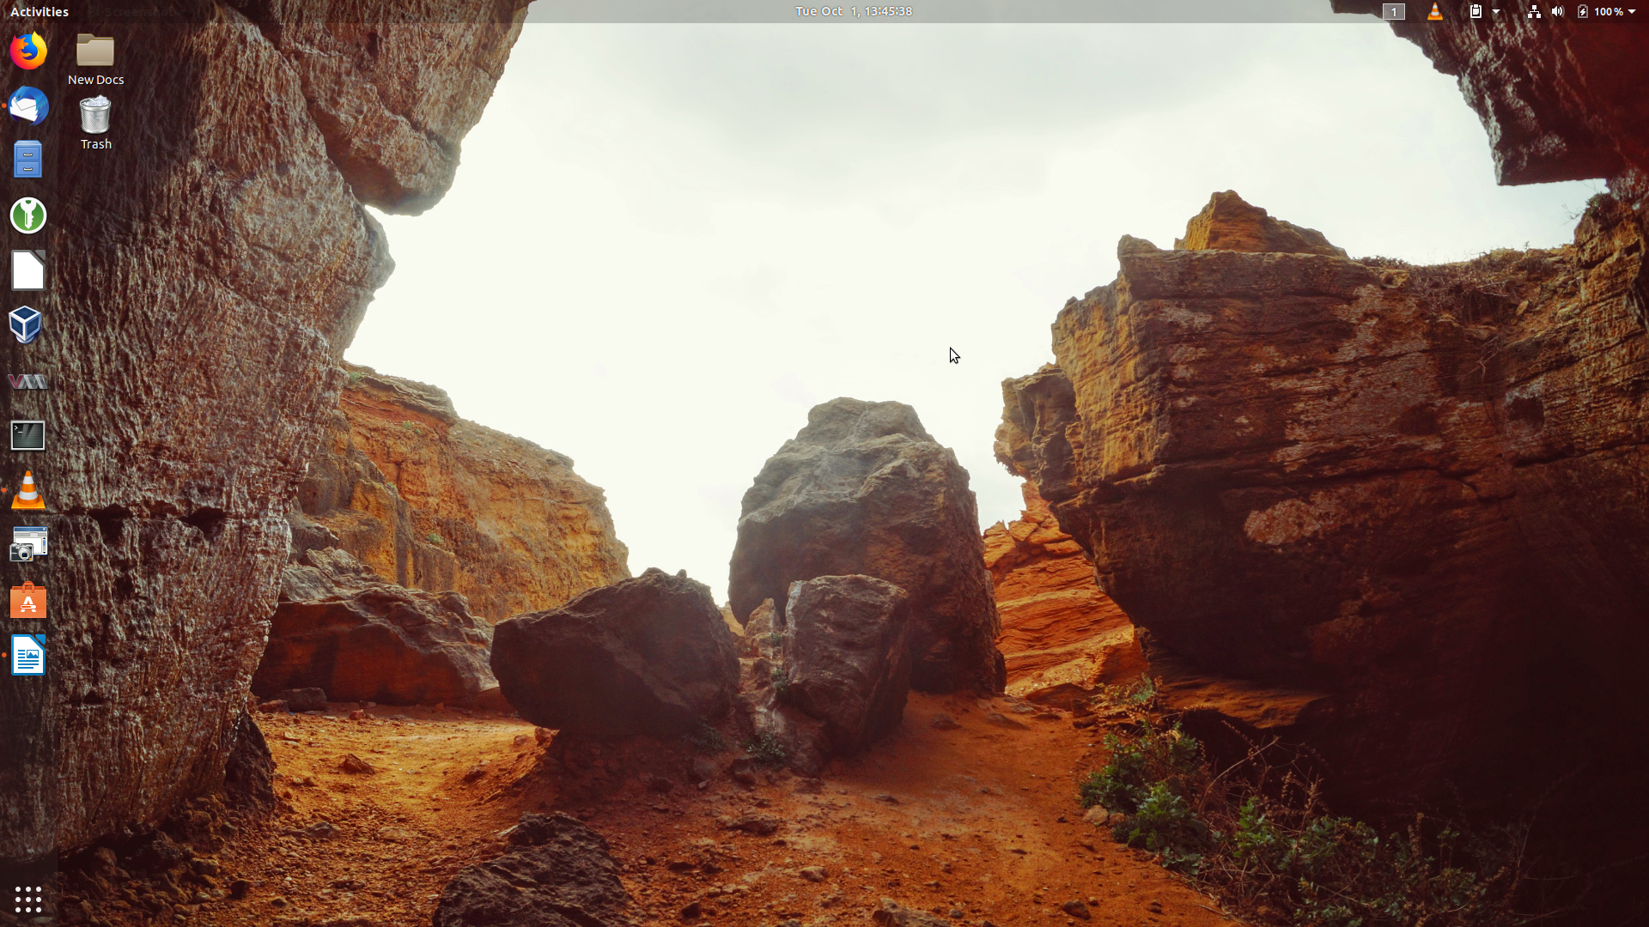
Figure 1. A Barren Desktop.

File System — We all use a hierarchical structure of directories in which we store our files. Storing is the easy part; it’s the retrieval that’s difficult. Using descriptive directory and file names will help greatly, although this may take some adjustment if you began using PCs in the DOS days, where you were limited to maximums of eight characters for filenames and three for extensions. I find it useful to have an archive directory where I move files and directories that I seldom need but haven’t worked up the courage to discard. Your file browser can help you identify candidates for trashing. Configure it to sort the files by their creation date, with the oldest shown first, and to display them as a list so you can see their creation dates, which will help you find old files that are no longer useful. My approach here is much like that for my desktop and menu bar; almost every file is in a directory with very few loose ones in my home directory; see Figure 2.

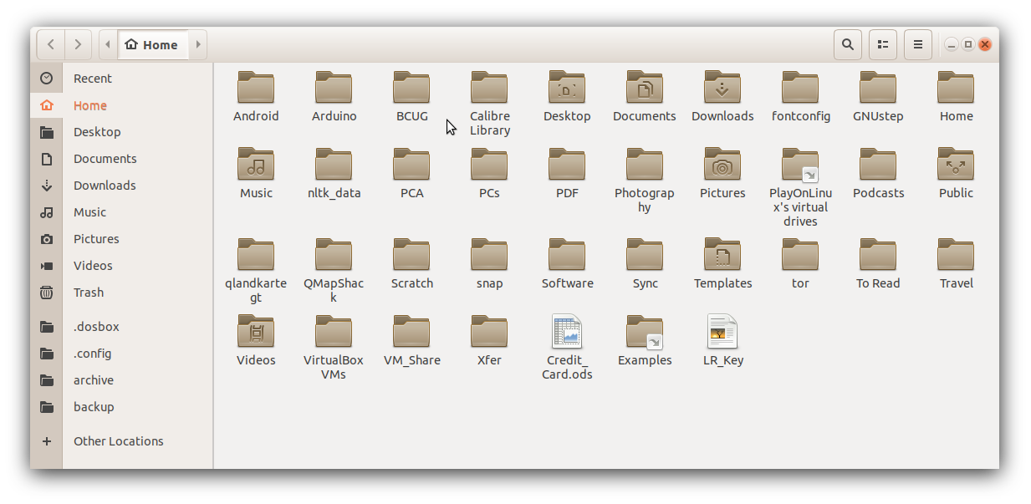
Figure 2. Home Directory.

Mail — Most of us also keep our messages far too long, with the result that our inboxes are overflowing. You can create folders and even sub-folders within your in-box with descriptive names, such as Orders, Travel, Finance, and Medical. Review your messages and discard those that are no longer useful, reservations for completed trips for example. The great majority of messages are worthless and should be deleted immediately. Many others are valuable for only a short time; I periodically delete all that are over a year old (and yet my inbox contains hundreds).

Favorites — I keep only my most-used few on my browser menu bar. The rest are organized in folders, so I can quickly find what I need. Here too, you should perform house cleaning and delete those that are obsolete or unused. Our interests change over time, and some sites that we used to check every day now just clutter our list. Many browsers provide a cloud service that synchronizes the favorites on all your devices, which greatly eases the job, assuming you use the same browser everywhere, of course.

Media — You may use specialized applications to store and retrieve photos, songs, and the like. Often, these can create playlists that access the files in the order you prefer, without having to duplicate or move the files. I prefer to keep my media files on my disk rather than in the cloud, although this means that I have to back them up. I also prefer to organize my media files using the file manager, although this means I have to rename them to make them appear in the correct order. Some years ago I used a photo organizing application for this, and when its vendor discontinued it, I lost several slide shows. I still had the photos, but they weren’t in a logical order and were no longer associated with the title slides.

Passwords — I consider a password manager application essential. This organizes them into folders and stores them in an encrypted database. Some also can store associated information, such as PINs, security questions and answers, and URLs. They also can generate strong passwords, which removes the temptation to use the same one on different accounts. I have no idea what most of my passwords are, but I don’t need to as they are available on my PC and cell phone, once I enter the database password (about the only one I do know). I use KeePassXC, https://keepassxc.org/, which is available for all operating systems, and there is a compatible variant for Android. As a result, my passwords are always available, but still secure. Figure 3 shows the application. I have some work to do here; there are far too many items in the Internet category, and I should split it up to make them easier to find.

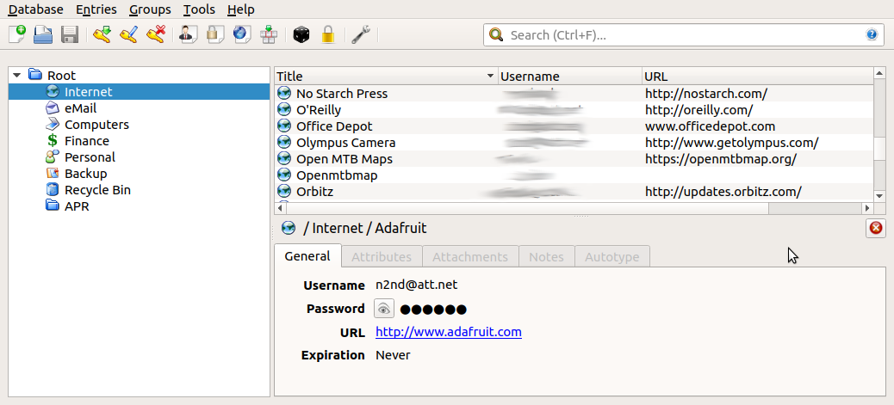
Figure 3. KeePassXC.

Notes — We all make notes, as the success of Post-it shows, and keeping track of them can be difficult. Fortunately, there are applications to help. I use CherryTree, https://www.giuspen.com/cherrytree/, which stores both formatted text and images and is available for Windows and Linux. I keep some only a short while, for example, while I gather information for an article, but some I retain and modify for years, for example, those on photography and PC operation. Each major topic is a separate file, and each is organized like a directory tree. Unfortunately, it has no cell-phone equivalent, but I can export the notes as a PDF for display on my cell phone. Figure 4 shows my notes file for this article.

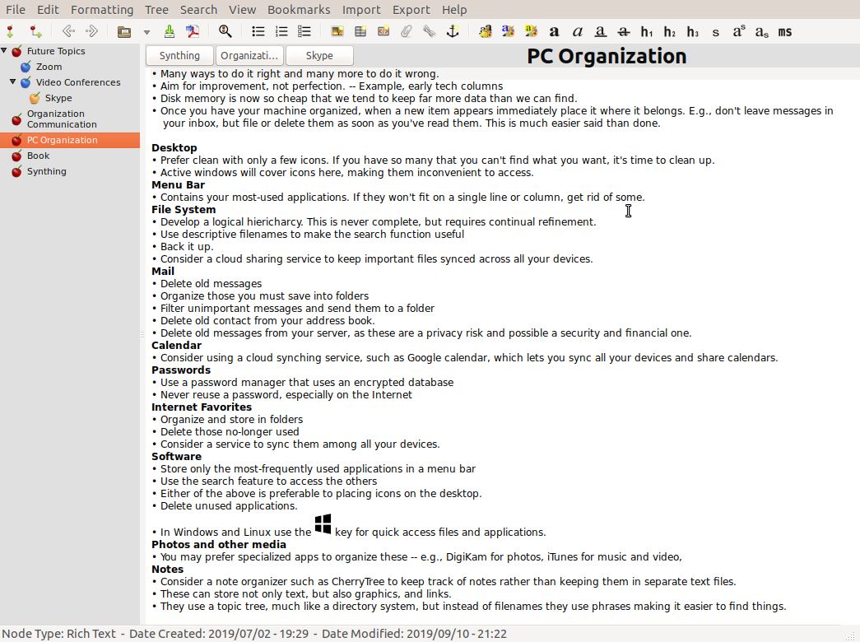
Figure 4. CherryTree Notes.

Organization is personal, and what I find efficient may frustrate you. Pay attention to how you spend your time, and if you find yourself repeating the same routines, look for ways to streamline them. Perhaps you can change how you store things, or there may be an application to make retrieval faster. Pay attention to the ten percent rule, “We spend 90 percent of our time on 10 percent of the tasks.”

